Research note on modelling backyarding: input into NEDUM Urban Simulation Model for Cape Town

Prepared by Claus Rabe

9 August 2017

Contents

Research note on modelling backyarding: input into NEDUM Urban Simulation Model for Cape Town 1

1 Intro 3

2 Definitions 3

2.1 Definition of backyard structure 3

2.2 Types of backyard structures 3

2.3 Common characteristics of backyard structures 4

2.4 Neighbourhood characteristics 4

2.4.1 Old Council housing 4

2.4.2 RDP housing 5

2.5 Services / physical living conditions 5

2.6 Landlords and tenants 6

2.6.1 The landlord’s decision to rent 6

2.6.2 The renter’s decision to rent 6

2.6.3 Tenant utility 7

2.6.4 Landlord’s decision to invest / upgrade 7

2.7 Micro-spatial drivers 8

2.8 Reported rentals based on case studies 9

3 Spatial analysis of municipal property data 11

3.1 Property values 11

3.2 Property size: 12

3.3 Land use 13

3.4 Zoning: 13

3.5 Number of backyard dwellings 14

3.6 Conclusion 14

4 Demographic characteristics of backyarding households 16

4.1 Backyard counts 16

4.1.1 Role of RDP housing 18

4.2 Gender 18

4.3 Household size 19

4.4 Number of structures per property 20

4.5 Household income 21

4.6 Race 22

4.7 Tenure status 23

5 Details on studies cited 24

6 References 24

**Tables**

Table 1. Observed rentals 1

Table 2. Backyard frequency, by Property values 1

Table 3. Backyarding frequency, by Property size 2

Table 4. Backyarding frequency, by Land use 3

Table 5. Backyarding frequency, by Zoning 3

Table 6. Number of backyard dwellings per property 6

Table 7. Composition of dwelling types, over time 8

Table 8. Households where main dwelling is RDP or government-subsidised 9

Table 9. Number of backyard households, by gender of household head 9

Table 10. Racial composition, by dwelling type 12

Table 11. Tenure status, by dwelling type 13

**Charts and figures**

Figure 1. Location of local case studies 2

Figure 2. Predicted and actual backyarding pattern 5

Figure 3. Backyard counts, per source (Cape Town) 7

Figure 4. Types of backyarding, Cape Town 8

Figure 5. Household size, informal dwellings vs. citywide 10

Figure 6. Household income, backyarding vs. citywide 11

Figure 7. Household income, informal backyarders vs. other informal shacks 11

Figure 8. Racial composition of backyarding households, per dwelling type 12

Figure 9. Backyarding households, by tenure status and dwelling type 13

# Intro

South Africa’s formal government-subsidised housing programme absorbs a large proportion of households ever year. However, the delivery of subsidised housing is insufficient to cater for all new households created annually, and the balance find accommodation in formal and informal structures in backyards, or in informal settlements.

This research note serves to assist the World Bank-CIRED team in the development of the NEDUM Urban Simulation model for Cape Town. In this research note, I summarise a review of South African research findings and conduct a spatial analysis for Cape Town using a combination of property data, surveyed observations and Census results. In doing so, key drivers are identified, and property characteristics which indicate propensity for backyarding are indicated.

# Definitions

## Definition of backyard structure

A backyard structure refers to:

1. a dwelling that has constructed without formal planning and building permission,
2. on a formally proclaimed residential property with at least one formal dwelling unit which is fully serviced,
3. constructed of any material, intended or used for human habitation.

## Types of backyard structures

Statistics South Africa differentiates between two types of backyard structures when conducting its Census. Since the wording of their definition is ambiguous and subject to misinterpretation, this research note uses an alternative, clearer wording which corresponds with the Community Survey definitions:

|  |  |
| --- | --- |
| Statistics South Africa definition | Our equivalent wording |
| 1. “House/flat/room in backyard” | Formal structure in backyard |
| 1. “Informal dwelling (shack, in backyard)” | Informal structure in backyard |

The distinction between these two types of backyard structures is based on the building material used for construction, rather than on the nature of the main dwelling or the ownership status of the land:

* Formal structures in backyards: these rooms or houses are built using approved building materials and are separated from the main house with access to services in the yard, and constructed using permanent building material (e.g. bricks). It is mostly found in townships and subsidised housing areas (Mahlakanya and Willemse 2017).
* Informal structures in backyards are either built using non-permanent building material like corrugated iron and wood that do not comply with building specifications. They are either built by the landlord with the intention to rent, or structures built by tenants on spaces rented from landlords.

## Common characteristics of backyard structures

Broadly speaking, backyarding shares the following characteristics:

* small-scale activity, seldom exceeding few units per property
* produced on privately owned land and State-owned land (notably Council-owned rental stock)
* procured and managed by private individuals
* accommodation is occupied by separate households or by extended family members or kin-networks
* tenant-landlord relationship is governed by private agreement, which may be formal or informal.

SALGA 2014

## Neighbourhood characteristics

Approximately one third of Cape Town’s existing housing stock is developed as part of the succession of government housing programmes during the course of the 20th and early 21st century[1]. The emergence of backyard dwelling corresponds closely with the roll-out of government-subsidised and fully serviced single or group housing properties, where surplus yard space created the opportunity for additional one- or two-roomed structures to be developed by the property owner, to accommodate family/kin or for rent.

Historically speaking, the proliferation of backyarding occurred on the back of two distinctive “waves” of government housing programmes: firstly, the roll-out of **Council housing** during the 1950s and 1960, and secondly, the roll-out of **RDP (and BNG) housing** since the 1990s.

### Old Council housing

The initial government housing programme was implemented in the 1950s and 1960s for Coloured and Black Africans during the height of Apartheid to accommodate migrant labour, with an emphasis on rental housing. Whereas the size of the main formal dwelling varied from 40-44m2 (Beall, Crankshaw, and Parnell 2003) the overall plot would range upward of 100m2, providing sufficient space for a brick garage to be converted to a dwelling, or for a one- or two-room structure to be built in the backyard. Although generalisation should be made with caution, the literature suggests that historically the relationship between the landlord and the tenant was different in Coloured neighbourhoods compared to Black African neighbourhoods: in Coloured areas, inhabitants of **old Council housing** bought their former council property and supplemented their income with both informal and formal backyard structures (*‘hokkies*’), predominantly accommodating relatives, with payment in kind, rather than formal tenants or financial rent (Lemanski 2009); in contrast, backyard dwellings in Black African townships were more likely to accommodate paying tenants than kin (Lemanski 2009). However, these distinctions have weakened with time.

Backyard subletting was safety valve to absorb the pressure of popular demand to access urban livelihoods. Although strictly illegal, it was generally overlooked by officials and the phenomenon grew rapidly during the 1970s and 1980s. From the late 1980s, as Apartheid state controls declined, the number of backyard dwellings multiplied. By 1987, 40% of formal houses in Johannesburg’s African townships had at least one backyard shack and 23% had formally built “garage” inhabited by subtenants.

By 1990, nearly 60% of Gauteng’s township properties hosted backyard dwellings. In Cape Town by the mid-1990s, 87% of township houses had backyards. In well-located, older townships like Gugulethu, backyard dwellings outnumber host dwellings. In Soweto, backyard shacks almost exceeded the number of formal houses by 1997 (Beall, Crankshaw, and Parnell 2003).

### RDP housing

The post-Apartheid era witnessed a new supply of backyard dwellings which were informally developed in the significant yard space of fully serviced, 40m2 housing units provided on serviced residential plots (average size 160m2) as part of the Reconstruction and Development Programme. Post-1994 South African housing policy is centered around the provision of fully state-funded home-ownership for the poor and seeks to eradicate informal housing, including backyard shacks. These are formal freestanding housing units provided on an ownership basis. Finance for the development and purchasing of such units is provided by a grant through the subsidy scheme system. The housing stock has been developed by private sector developers under contract to government.

However, RDP settlements massively increased the opportunity for backyarding to emerge. This is because RDP settlements offer a new location for backyard dwellings, providing additional accommodation and/or rental income to housing beneficiaries. For tenants, backyard dwellings gradually became an attractive form of housing for smaller households and new entrants to the city (Lemanski 2009).

## Services / physical living conditions

The provision of services and the quality of accommodation available to the residents of backyards are significantly better than those available in the squatter camps.

1. Landlords typically share electricity, water, sanitation and refuse collection with backyard tenants, in return for rent. They merge into existing residential areas and function alongside neighbours with formal tenure rights and access to infrastructure and services (Lemanski 2009).
2. Virtually all backyard accommodation, whether formal (89%) or shack (93%), has only one room (Lemanski 2009)
3. Although very few backyards have a legal connection to an electricity meter (5%), almost all backyard households have some access to electricity. Most get their electricity through an illegal cable from the main house (86%).
4. Similarly, because backyard taps were originally fixed to an outside wall of the council houses, almost every backyard household (99%) had access to water. With few exceptions, neither residents of the main structure nor backyard tenants have water in the house unless they have it piped at their own expense.
5. In addition, because almost all council stands were provided with outside toilets, all backyard tenants have access to flush toilet.

## Landlords and tenants

Although differences between backyard tenants and owner-occupier landlords should not be exaggerated, some significant social difference exist. A study of backyarding in Greater Soweto indicated the following differences:

1. the most important difference relates to the fact that backyard tenants are more recent arrivals to Greater Soweto. Approximately two-thirds of landlords in “matchbox” housing arrived between 1946 and 1965.
2. Secondly, backyard tenants are significantly younger than their landlords (36 vs 56 years for household heads).
3. Landlords are 10 time more likely to be retired and twice as likely to be married.
4. Backyard tenants are more likely to be foreign immigrants than their landlords.
5. The vast majority of younger people are asset poor, having no homes and relying on renting backyard shacks and paying their landlords disproportionately for services.

### The landlord’s decision to rent

The new owners of RDP houses acquired their houses for free, but the improvement in their living conditions in most cases was not accompanied by an improvement in their financial status. Most of these inhabitants remained unemployed or with insecure or intermittent employment. The new home owners soon exploited one of the few resources at their disposal, namely space, by erecting informal or makeshift dwellings in their backyard (Govender, Barnes, and Pieper 2011).

For head of household in township or RDP house, the decision to rent is based on the need to supplement or gain an income by way of renting a shack (Braude 1996). These houses are not ‘owned’ by the state or the local authority any longer and the present indigent owner does not have the financial ability or skills to maintain the house.

Very few of the backyard dwellers living in RDP area are relatives of the dwellers in the main house. The situation therefore represents predominantly a landlord-renter relationship. (Govender, Barnes, and Pieper 2011).

### The renter’s decision to rent

Why do poor people live in backyard dwellings, dependent on landlords and liable for rent, rather than move to an informal settlement and experience an independent and rent-free lifestyle? The principal reasons identified are positive agency factors such as **access to services**, **location** and **flexibility**, and reduced threat of eviction, in addition to structural reasons related to the failures of the housing policy.

Who rents in backyards? Generalisations about backyarders are not possible nor advisable: backyard tenants may be small households, households who don’t qualify for a housing subsidy, multi-nodal households, those who prefer to rent, and people who only require temporary or short-term accommodation. Many backyard tenants prefer a rental arrangements and are not seeking to buy a house of access housing (SALGA Position on Backyarders, 2014).

For poor households reliant on informal and irregular employment, backyard shacks offer flexibility to respond to changing employment opportunities, compared to static residence in a periphery settlement Thus, for some households, renting backyard space may better facilitate their livelihood strategies than renting or owning (in)formal property in a set location. A backyard dwelling close to employment can be cheaper than a township property, reducing transport costs and with set rental rather than changing council rates and service payments. In particular, new arrivals to the city, requiring cheap accommodation close to employment opportunities, are predominantly attracted to backyard housing (Lemanski 2009).

Backyard shacks are relatively low cost, rent payments are flexible and evictions uncommon. This is attractive to recent rural and foreign migrants. Backyards are often preferred to free-standing shacks because access to basic services is better. Third, backyards seem to enjoy **locational advantage** over informal settlements, such as access to local shops and amenities, and employment outside the area. Backyards reflect a more deliberate choice over free-standing shacks or vacant sites elsewhere in the city because of their proximity to economic opportunities, superior access to public services and greater personal safety (Beall, Crankshaw, and Parnell 2003).

Contrary to common belief, there is a consensus across studies that backyard dwellers are typically better educated and had a higher education rate and income when compared to the inhabitants of the main house. Backyard dwellers must seek employment and generate an income as they have to pay rent and water and electricity usage to the owner of the main house or face eviction (Govender, Barnes, and Pieper 2011).

### Tenant utility

According to the findings of a recent Quality of Life Survey for backyarders in Gauteng province, households living in informal structures in backyards experienced the biggest improvement in quality of life compared to households living in formal structures in backyards, or informal structures not in backyards (in other words, in informal settlements).

The improvements in the quality of life of households living in informal backyard structures could be attributed to the informal structures being more affordable than formal structures, giving informal backyard dwellers more money to spend on other necessities like household goods, education and services, which positively influences QoL.

Formal backyard tenants have better socio-economic QoL because most of them have secondary education that improves their employment prospects and income levels. Formal backyard tenants mostly earn middle-incomes. Informal backyard tenants and those households living in informal settlements show no statistically significant differences in their education levels. However, whereas informal backyard tenants earn low income, while free-standing informal tenants typically earn no incomes.

(Mahlakanya and Willemse 2017)

### Landlord’s decision to invest / upgrade

From a modelling perspective, it is important to interrogate why – given the clear demand for housing evident in the horizontal expansion of almost every RDP unit to accommodate backyard dwellers, land in South Africa in relatively well-located State-subsidised areas are not more intensively used through re-investment in better building material and multi-storey development (in other words, substituting capital for land). Why do landlords do not invest in the backyard structures in order to realise higher rentals? Why are 78% of backyard structures on RDP plots in Cape Town[2] built from wood and corrugated iron? In some locations, upwards of 90% of backyard structures are built from temporary material.[3]

This question is investigated in depth in a recent study by McGaffin, Cirolia, and Massyn 2015. Firstly, the authors point out that informalisation is originally driven

“by delays in the title deed transfer process and the high cost to transfer properties, discouraging formal registration and leading to a vibrant secondary market which lacks formal title and thus the ability to fully capitalise on the housing asset”.

This however does not explain why incremental improvements to housing quality and density does not occur? To this end, the authors posit three potential explanations for why this does not happen in South Africa:

1. **The impact of the capital subsidy programme** : the RDP programme, by setting a fixed capital grant amount and stipulating minimum floor area and land use standards, determines that the cost of land is the only variable unit into a public housing development. Therefore, the more remote the housing development, the lower the land price and consequently the more feasible the project.
2. **The capital threshold (or hurdle):** capital thresholds required to successfully substitute capital for land restricts the substitution process. The cost of constructing a structure that can support several floors is beyond the means of a low-income household. Thus, the only way that the poor can increase rentals is by consuming less floor space (e.g. smaller units or multiple household occupancy).
3. **The socially drive nature of property markets and land use decisions**: according to a 2004 review of the South African township residential property market, the primary importance attached to a house by a household was that of shelter and accommodation of family members. The review found that 70% of persons interviewed said that improvements to their house had been done to increase the size and amenity value of their houses, 25% of improvements were done to increase the resale value and only 2% of improvements were done to generate rental income.

## Micro-spatial drivers

Whilst having a relatively even distribution of sites accommodating backyard shacks, concentrations are found responding to proximity to schools, access to railway station, proximity to township centre, shops (Braude 1996).

## Reported rentals based on case studies

Rentals paid by backyarding tenants to landlords are not systematically recorded, but is inferred from local surveys conducted either by the City of Cape Town or by academics. The results are reported in the table below:

Table 1. Observed rentals

|  |  |  |  |  |  |  |  |  |
| --- | --- | --- | --- | --- | --- | --- | --- | --- |
| Source | Location | Sample | % temporary building material | % rent paying | Rent | Services | Total rent + service  (weighted average) | Real rental  (2017) |
| CCT 2011 | Factreton, Cape Town | 232 (council)  887 (private) | 98% (council)  82% (private) | 77% (council)  64% (private) | R232 (council)  R480 (private) | R107 (council)  R205 (private) | R602 (2011) | R823 (2017) |
| CCT 2011 | Hanover Park, Cape Town | 1166 (council)  718 (private) | 62% (council)  62% (private) | 65% (council)  70% (private) | R261 (council)  R390 (private) | R199 (council)  R268 (private) | R539 (2011) | R737 (2017) |
| CCT 2011 | Langa, Cape Town | 662 (council)  4418 (private) | 92% (council)  82% (private) | 40% (council)  32% (private) | R264 (council)  R328 (private) | R106 (council)  R119 (private) | R435 (2011) | R595 (2017) |
| Cirolia and McGaffin 2015 | Du Noon, Cape Town | 28 (private) |  |  |  |  | R755 (2014) | R872 (2017) |
| CCT 2017 | Pelikan Park,  Cape Town | *pending* |  |  |  |  |  |  |
|  |  |  |  |  |  |  |  |  |

Figure 1. Location of local case studies

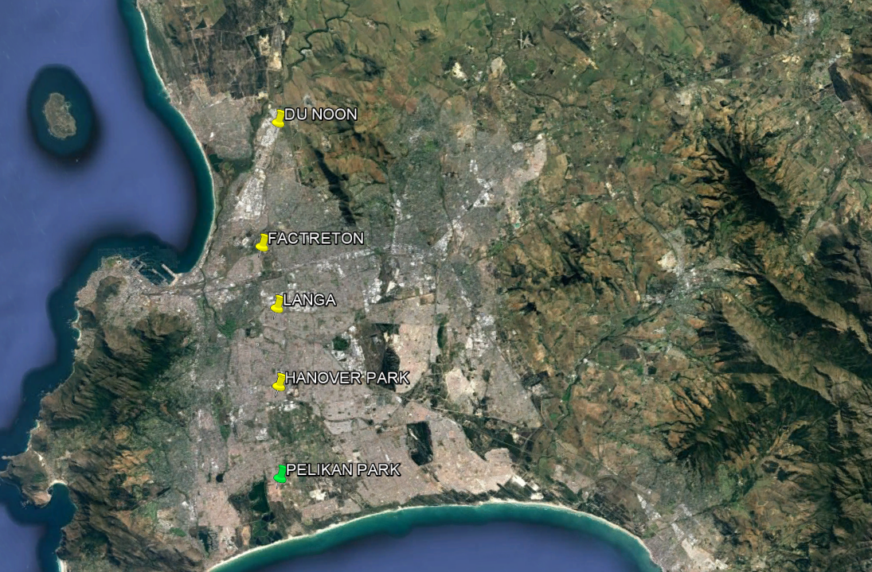

# Spatial analysis of municipal property data

By overlapping the backyard point data with the 2012 and 2015 property valuation dataset, it is possible to identify the common characteristics associated with properties with backyarding.

## Property values

91% of properties where backyarding is present is valued between R100 00 and R600 000.

Table 2. Backyard frequency, by Property values

|  |  |  |
| --- | --- | --- |
| *Bin* | *Frequency* | *% of Total* |
| 0 | 52 |  |
| 50000 | 1088 | 2% |
| 100000 | 5801 | 10% |
| 150000 | 702 | 1% |
| 200000 | 2560 | 4% |
| 250000 | 12118 | 21% |
| 300000 | 11544 | 20% |
| 350000 | 7847 | 14% |
| 400000 | 3669 | 6% |
| 450000 | 2894 | 5% |
| 500000 | 2984 | 5% |
| 550000 | 1970 | 3% |
| 600000 | 1081 | 2% |
| 650000 | 762 | 1% |
| 700000 | 523 | 1% |
| 750000 | 368 | 1% |
| 800000 | 239 | 0% |
| 850000 | 170 | 0% |
| 900000 | 112 | 0% |
| 950000 | 81 | 0% |
| 1000000 | 125 | 0% |

Own calculations

City of Cape Town General Valuations 2015

## Property size:

89% of properties where backyarding is present is between 125 and 400 square metres in size.

Table 3. Backyarding frequency, by Property size

|  |  |  |
| --- | --- | --- |
| *Bin* | *Frequency* |  |
| 0 | 4 | 0% |
| 50 | 22 | 0% |
| 75 | 329 | 1% |
| 100 | 542 | 1% |
| 125 | 3200 | 6% |
| 150 | 4749 | 8% |
| 175 | 8409 | 15% |
| 200 | 8091 | 14% |
| 225 | 7041 | 12% |
| 250 | 5087 | 9% |
| 275 | 4722 | 8% |
| 300 | 4363 | 8% |
| 325 | 2459 | 4% |
| 350 | 1513 | 3% |
| 375 | 879 | 2% |
| 400 | 720 | 1% |
| 425 | 578 | 1% |
| 450 | 523 | 1% |
| 475 | 896 | 2% |
| 500 | 1025 | 2% |

Own calculations

City of Cape Town General Valuations 2015

## Land use

The City of Cape Town uses land use categories in furtherance of property valuations. This land use assignment refers to the dominant use on a given property.

Although the greatest proportion of A10 and group housing (D02 and D01) has backyarding, single residential (A01) is the most commonly occurring land use category (317 438). 17% of properties with this land use has backyarding in 2012. This proportion is the same in 2015.

Table 4. Backyarding frequency, by Land use

|  |  |  |  |  |
| --- | --- | --- | --- | --- |
| Dominant land use on property | CODE | Prop. count | Prop. count w/ backy. structures | Freq. |
| Informal residential structure | A10 | 7 266 | 1 959 | 27% |
| Block of flats | D02 | 1 216 | 277 | 23% |
| Hotel | D01 | 256 | 53 | 21% |
| One single residential dwelling | A01 | 317 438 | 53 308 | 17% |
| Informal settlement | D11 | 58 | 8 | 14% |
| Two single residential dwellings | A02 | 23 284 | 2 468 | 11% |
| Terraced/multi-dwelling | D07 | 180 | 19 | 11% |
| Residential detached structures | A09 | 1 142 | 120 | 11% |
| *Grand Total* |  | *537 996* | *58 941* | *11%* |

Own calculations

City of Cape Town General Valuations 2015

## Zoning:

Below is the results for zoning. Zoning is not considered in this analysis.

Table 5. Backyarding frequency, by Zoning

|  |  |  |  |
| --- | --- | --- | --- |
| Zoning | Count | Number | Freq. |
| Single Dwelling Residential | 140733 | 22287 | 16% |
| Residential I | 28602 | 17035 | 60% |
| Informal Residential | 25530 | 4771 | 19% |
| Single Residential | 85573 | 3987 | 5% |
| General Residential R12 | 9022 | 3436 | 38% |
| Single Residential 1 | 5541 | 2463 | 44% |
| Single Residential 2 | 3668 | 1690 | 46% |
| Housing Scheme Areas | 1449 | 704 | 49% |
| General Residential (GR1) | 5280 | 411 | 8% |
| Single Residential Including (Sub Zone A) | 8635 | 393 | 5% |

Own calculations

City of Cape Town General Valuations 2015

## Number of backyard dwellings

Table 6. Number of backyard dwellings per property

|  |  |  |  |  |  |  |  |
| --- | --- | --- | --- | --- | --- | --- | --- |
|  |  | Number of backyard dwellings | | | | | |
|  |  | 1 | 2 | 3 | 4 | 5 | >5 |
| All properties | Count of properties | 42107 | 10414 | 3720 | 1381 | 585 | 734 |
| % of citywide | 7.8% | 1.9% | 0.7% | 0.3% | 0.1% | 0.1% |
| Single residential properties | Number of properties | 38212 | 9414 | 3418 | 1273 | 525 | 466 |
| % of citywide | 12.0% | 3.0% | 1.1% | 0.4% | 0.2% | 0.1% |

Own calculations

City of Cape Town General Valuations 2015

## Conclusion

On the basis of above, a backyard prone layer is developed based on the following criteria:

* Property values R100-600k
* Property size 125-400m2
* Land use Single dwelling residential ( A* )

General residential ( D* )

A visual inspection is the resultant layer accurately captures the distribution of points previously recorded, and validation using aerial photography indicates neighbourhoods where the resultant layer where backyarding is evident but not captured by the City point data.

By aggregating the properties which meet these requirements into generalised polygons, 123 781 of the 130 676 backyard observations (95%) are captured (see below).

Of the 195 577 properties which meet this set of criteria, 118 569 contain or are within 100m of an observed backyard. In other words, there is a 61% probability that a property meeting the above characteristics which contains, or has a close neighbour which contains, at least one backyard dwelling. Given that these observations are incomplete, it is likely that this probability is greater than 61%. Earlier studies showed that, within the townships in Cape Town, the proportion of backyard dwellings to formal dwellings ranged from around 60% in poorly located areas (e.g. Khayelitsha) to over 100% in well-located areas (e.g. Gugulethu).

Figure 2. Predicted and actual backyarding pattern

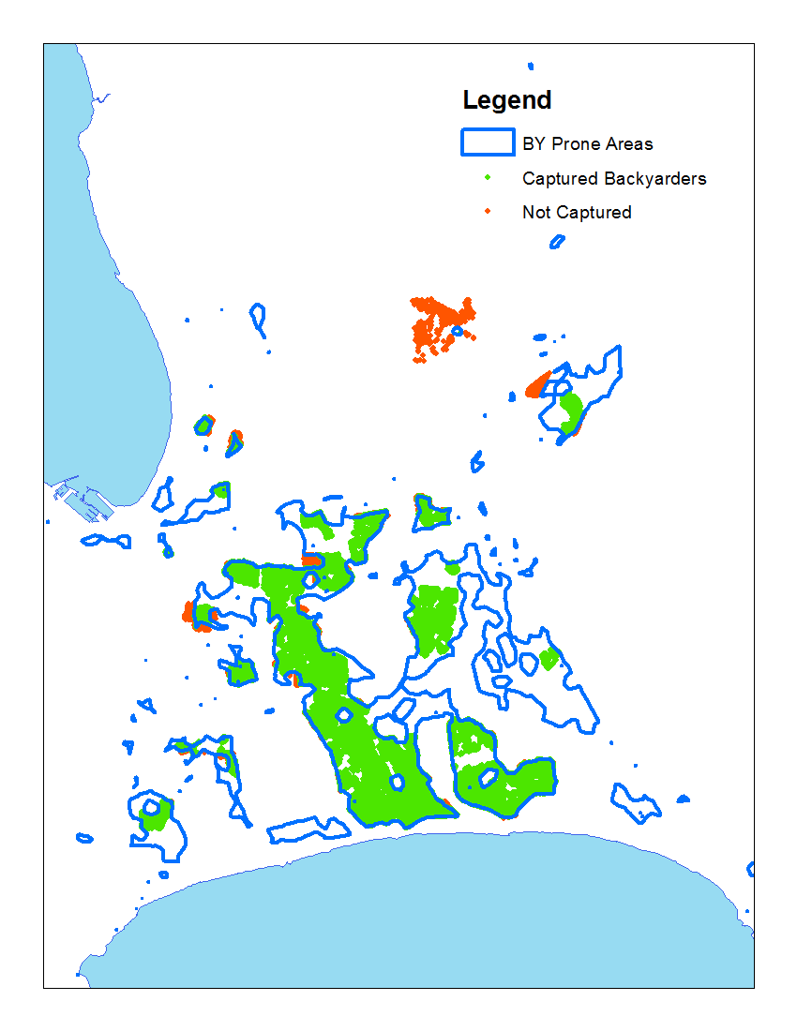

Own visualisation

City of Cape Town General Valuations 2015

City of Cape Town Backyarder Survey 2012

# Demographic characteristics of backyarding households

## Backyard counts

The Census 2011 results for backyarding vary significantly with the City of Cape Town’s manual aerial survey which was used in the preceding analysis, and is more closely aligned to the results of the Community Survey 2016. The Census 2011 results indicated 74 955 households living in informal structures in backyards and 91 233 households living in both formal and informal structures in backyards. The Community Survey 2016 results for Cape Town, which uses a representative sample, indicated the number of persons in backyards. When Census 2011 household sizes are applied (i.e. 2.95 persons per household for formal in backyard, and 2.52 persons per household living in informal structure in backyard), the results indicate a marginal increase in informal structures, but a significant increase in formal structures in backyards.

Figure 3. Backyard counts, per source (Cape Town)

Own calculations

City of Cape Town Aerial Survey

Census 2001, Census 2011

Community Survey 2016

Figure 4. Types of backyarding, Cape Town

Own calculations

Census 2001, Census 2011

Community Survey 2016

Caution is warranted when comparing different backyarding subsectors over time, given the definitional inconsistences differentiating these categories. Broadly speaking, however, the number of households living in either formal or informal structures in backyards have increased at an average annual rate of 6.4% between 2001 and 2011, and at 6.7% between 2011 and 2016. This is significantly higher than the 3.6% growth in households overall during this time.

Table 7. Composition of dwelling types, over time

|  |  |  |  |  |  |  |
| --- | --- | --- | --- | --- | --- | --- |
|  | Census 2001 | % | Census 2011 | % | Community Survey 2016 | % |
| Formal structure not in backyard | 599 784 | 77% | 821 217 | 77% | 965 465 | 79% |
| Formal and informal structure in backyard | 52 124 | 7% | 91 233 | 9% | 117 956 | 10% |
| Informal structures not in backyard | 110 139 | 14% | 143 817 | 13% | 136 890 | 11% |
| Other | 15 346 | 2% | 8 708 | 1% | 8 708 | 1% |
| TOTAL | 777 393 |  | 1 068 525 |  | 1 229 019 |  |

The proportion of households residing in formal dwellings not in backyards have increased marginally from 77% to 79% between 2001 and 2016, whereas the proportion of households residing in informal structures in backyards have declined from 14% in 2001 to 11% in 2016. The proportion of households living in either formal and informal dwellings in backyards have increased steadily from 7% in 2001 to 10% in 2016. Based on these trends, it is expected that the number of households living in backyards will exceed the number of persons living in informal settlements.

### Role of RDP housing

As previously discussed, backyarding occurs in two contexts: firstly, on old Council properties developed in the 1950s and 1960s; more recently, backyarding has occurred on RDP plots. Although the Census data does not differentiate between these two contexts, the Community Survey 2016 data does ask whether the main dwelling that household currently lives in is an RDP or government subsidised house.

Table 8. Households where main dwelling is RDP or government-subsidised

|  |  |  |  |
| --- | --- | --- | --- |
|  | Yes | Total | % |
| Formal structure not in backyard | 336 034 | 965 529 | 35% |
| Formal structures in backyard | 15 342 | 38 942 | 39% |
| Informal structures in backyard | 10 345 | 79 014 | 13% |
| Informal structures not in backyard | 5 907 | 136 890 | 4% |
| Other | 870 | 8 708 | 10% |
| TOTAL | 368 498 | 1 229 083 | 30% |

Own calculations

Community Survey 2016

## Gender

Table 9. Number of backyard households, by gender of household head

|  |  |  |  |
| --- | --- | --- | --- |
|  | Male-headed | Female-headed | Male as % of total |
| House/flat/room in backyard | 9 948 | 6 333 | 61% |
| Informal dwelling (shack; in backyard) | 47 652 | 27 306 | 64% |
| Room/flatlet on a property or larger dwelling/servants’ quarters/granny flat | 6 117 | 4 092 | 60% |
| All households | 660 525 | 408 015 | 62% |

Own calculation

Census 2011

Households in shacks in backyards are more likely to be male-headed than other forms of backyarding, and marginally more likely to be male-headed compared to the overall population. This observation compares favourably to case study findings (Lemanski 2009; Govender, Barnes, and Pieper 2011) that households who reside in shacks in backyards are more economically active and mobile than households who live in the principal structure of the property.

## Household size

Figure 5. Household size, informal dwellings vs. citywide

Census 2011

* Informal shacks in backyards are significantly more likely to consist of a single person than the overall population, and less likely to consist of 4 or more persons.
* This is in line with the general observation made elsewhere that this type of household is more mobile and economically active than the general population.
* The pattern which reflect social atomisation and multi-location households as an economic resilience strategy have important implications for housing demand and housing policy (e.g. backyard renting is seen as a temporary state, which results in municipalities usually not extending services to these residents).

## Number of structures per property

Figure 6. Number of backyard structures per property

CCT 2011 Surveys

|  |  |  |  |  |  |  |  |  |  |  |  |  |  |  |
| --- | --- | --- | --- | --- | --- | --- | --- | --- | --- | --- | --- | --- | --- | --- |
|  |  | 0 | 1 | 2 | 3 | 4 | 5 | 6 | 7 | 8 | 9 | 10 | >10 | Total |
| Langa | Council | 41% | 21% | 16% | 10% | 6% | 3% | 1% | 1% | 1% | 0% | 0% | 0% | 3185 |
| Private | 88% | 5% | 3% | 2% | 1% | 0% | 0% | 0% | 0% | 0% | 0% | 0% | 2280 |
| Factreton | Council | 23% | 43% | 20% | 10% | 4% | 1% | 0% | 0% | 0% | 0% | 0% | 0% | 178 |
| Private | 63% | 27% | 7% | 2% | 1% | 0% | 0% | 0% | 0% | 0% | 0% | 0% | 1151 |
| Hanover Park | Council | 55% | 38% | 5% | 1% | 0% | 0% | 0% | 0% | 0% | 0% | 0% | 0% | 2336 |
| Private | 70% | 27% | 3% | 0% | 0% | 0% | 0% | 0% | 0% | 0% | 0% | 0% | 1581 |

## Household income

Figure 7. Household income, backyarding vs. citywide

Census 2011

Figure 8. Household income, informal backyarders vs. other informal shacks

Census 2011

* Backyarders generally tend to be poorer than the overall population, with a dramatic drop in propensity for backyarding once a household earns greater than R76 801/pa.
* However, backyarder households in shacks (as opposed to more formal structures) tend to be marginally better off economically compared to households who live in shacks in informal settlements. This underscores the economic rationale behind backyarding.

## Race

Figure 9. Racial composition of backyarding households, per dwelling type

Census 2011

Table 10. Racial composition, by dwelling type

|  |  |  |  |  |
| --- | --- | --- | --- | --- |
|  | Black African | Coloured | Indian or Asian | White |
| House/flat/room in backyard | 6 717 | 6 957 | 207 | 1 944 |
| Informal dwelling (shack; in backyard) | 54 501 | 18 081 | 150 | 336 |
| ALL | 444 777 | 358 614 | 14 268 | 232 806 |

Census 2011

* Black Africans are the most likely to enter backyarding arrangements (i.e. relative their ethnic population in Cape Town), followed by Coloured households and then Whites and Asians.
* Similarly, there is a 65% likelihood that a backyarding households is Black African, followed by 30% Coloured and less than 4% White.
* However, the dwelling type of backyarding varies across ethnic groups. Whereas more formal types of backyarding tend to reflect the overall racial composition of city, informal shacks in backyards are predominantly Black African and formal structures tend to be disproportionately occupied by Coloured households.

## Tenure status

Figure 10. Backyarding households, by tenure status and dwelling type

Census 2011

More than half of households living in backyards rent, compared to less than 30% of all households. Households living in informal structures in backyards are more likely to rent (59%) than households living in formal structures in backyards (54%).

Table 11. Tenure status, by dwelling type

|  |  |  |  |  |  |
| --- | --- | --- | --- | --- | --- |
|  | Rented | Owned but not yet paid off | Occupied rent-free | Owned and fully paid off | Other |
| House/flat/room in backyard | 8 823 | 1 548 | 1 638 | 3 690 | 573 |
| Informal dwelling (shack; in backyard) | 43 983 | 2 016 | 11 049 | 15 066 | 2 841 |
| ALL | 319 332 | 223 437 | 139 203 | 355 239 | 31 314 |

# Details on studies cited

Cape Town Study (Govender, Barnes, and Pieper 2011)

* Four subsidized housing communities were selected within the City of Cape Town Metropole (CCTM) to participate in this cross-sectional survey. Statistical findings of 1080-person survey in two neighbourhoods

Reference list of studies

|  |  |  |
| --- | --- | --- |
| Sapire and Schlemmer | Gauteng | 1990 |
| Palmer Dev Group | Across SA | 1994 |
| Watson | Cape Town | 1994 |
| Watson and McCarthy | Gugulethu  Johannesburg | 1998 |
| Crankshaw | Soweto | 2000 |
| Morange | Port Elizabeth | 2002 |
| Bank | East London | 2007 |
| Lemanski | Westlake | 2009 |
| HSRC | Eastern Cape | 2010 |
| Govender | Cape Town | 2009 |
| Rubin and Gardner |  | 2013 |

(Turok and Borel-Saladin 2016)

# References

Beall, Jo, Owen Crankshaw, and Susan Parnell. 2003. “Social Differentiation and Urban Governance in Greater Soweto.” *Emerging Johannesburg e Perspectives on the Postapartheid City*, 197e214.

Braude, Sarah. 1996. “An Analysis of the Causes and Issues Surrounding Backyard Shack Development and the Implications for Policy : The Case of Umlazi.” Dissertation. University of KwaZulu Natal. https://researchspace.ukzn.ac.za/handle/10413/2583.

Govender, Thashlin, Jo M. Barnes, and Clarissa H. Pieper. 2011. “The Impact of Densification by Means of Informal Shacks in the Backyards of Low-Cost Houses on the Environment and Service Delivery in Cape Town, South Africa.” *Environmental Health Insights* 5 (May): 23–52. doi:10.4137/EHI.S7112.

Lemanski, Charlotte. 2009. “Augmented Informality: South Africa’s Backyard Dwellings as a by-Product of Formal Housing Policies.” *Habitat International* 33 (4): 472–484.

Mahlakanya, Itumeleng, and Lodene Willemse. 2017. “The Changes in the Quality of Life of Rented Free-Standing and Backyard Shack and Backyard Room Tenants in the Three Gauteng Metropolitan Municipalities.” *Urban Forum*, April, 1–20. doi:10.1007/s12132-017-9308-1.

McGaffin, Robert, Liza Rose Cirolia, and Mark Massyn. 2015. “Overcoming the Challenge of Vertical Consolidation in South Africa’s Low-Income Settlements: A Case Study of Du Noon.” In *Urban Forum*, 26:59–75. Springer. http://link.springer.com/article/10.1007/s12132-014-9232-6.

Turok, Ivan, and Jackie Borel-Saladin. 2016. “Backyard Shacks, Informality and the Urban Housing Crisis in South Africa: Stopgap or Prototype Solution?” *Housing Studies* 31 (4): 384–409.

1. Community Survey 2016
2. Community Survey 2016
3. City of Cape Town Backyarder Surveys